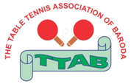 | THE TABLE TENNIS ASSOCIATION OF BARODA  (City & District): Vadodara  (Affiliated to: Gujarat State Table Tennis Association) | 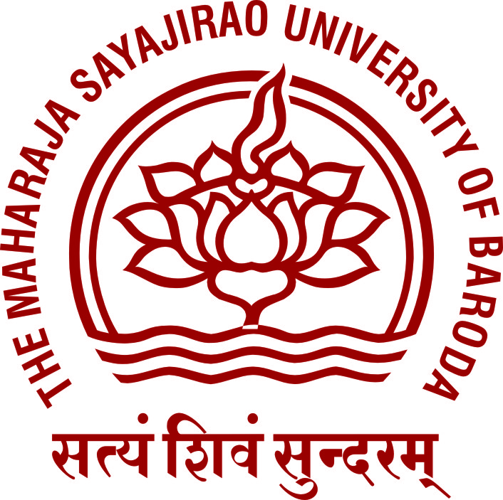

2ND OPEN BARODA MAJOR RANKING TABLE TENNIS CHAMPIONSHIPS-2017

Venue: TTAB-MSU TT Centre, Union Pavilion, The Maharaja Sayajirao University, Fatehgunj, Vadodara.
From: 6nd to 8th July 2017. Last Date for Entry: 3rd July 2017; before 7:30 pm
 ENTRY FORM 

- Name of the Player/Official:___________________________________________________________

- Date of Birth: _________________________ (DD/MM/YYYY)

- Name of the School/Institute: _______________________________ Contact No. (O) ____________

- Father’s Name: _________________________________________ Contact No. (O) _______________

- Contact No. (R)_____________ (M)_________________ Email________________________________
 EVENTS 
 | Men’s Singles | AGE CRITERIA | Women’s Singles
 | Youth Boys Singles | (21 Yrs) Born on or after 01/01/1997 | Youth Girls Singles
 | Junior Boys Singles | (18 Yrs) Born on or after 01/01/2000 | Junior Girls Singles
 | Sub Junior Boys Singles | (15 Yrs) Born on or after 01/01/2003 | Sub Junior Girls Singles
 | Cadet Boys Singles | (12 Yrs) Born on or after 01/01/2006 | Cadet Girls Singles
 | Veteran 40+ Men’s Singles |  | Veteran 40+ Women’s Singles
 | Veteran 50+ Men’s Singles |  | Veteran 60+ Men’s Singles
 ENTRY FEES 
Rs.100/- for each singles event & Registration fees Rs.100/-.
Total Fees Paid Rs. _______.

: PLEASE NOTE :
- All players/officials/members (as applicable) have to deal with other District/State/National association through TTAB only so far as Table Tennis is concerned.
- Name/entry will be accepted/forwarded only of that player, who will submit his/her entry in the prescribed entry form duly filled up along with entry fees. Once the name/entry forwarded to the organizing association, “No Refund is Admissible” according to the GSTTA.
- Withdrawal of entry should be informed well in advance in written, so as enable us to inform the organizing association accordingly.
- In case of any untoward incident, injury due to any reason whatsoever happens to anybody or loss of any valuable things or belongings in or outside the tournament/Championships/coaching premises, TTAB will not be held responsible for the same.
- All the players/officials/members (as applicable) shall fill up entry form individually and submit to TTAB office, 40-Aditya Bungalows, Near Keya Motor, Chhani Jakat Naka, Vadodara-390002 or TTAB–MSU TT Centre, Union Pavilion, The Maharaja Sayajirao University of Baroda, Fatehgunj, Vadodara.

Declaration: I have noted the above and undertaken to abide by the rules & regulations of TTAB.

Date: July 2017 Signature of Player’s/Parent’s: _________________
R E C E I P T

Received with thanks a sum of Rs.____________ from _______________________________________________ towards the Entry/Registration Fees for participating in the 2nd Open Baroda Major Ranking Table Tennis Championships–2017 which will be held at TTAB-MSU TT Centre, Union Pavilion, The Maharaja Sayajirao University, Fatehgunj, Vadodara from 6nd to 8th July 2017.

Date: July 2017Organizing Secretary: _______________________

