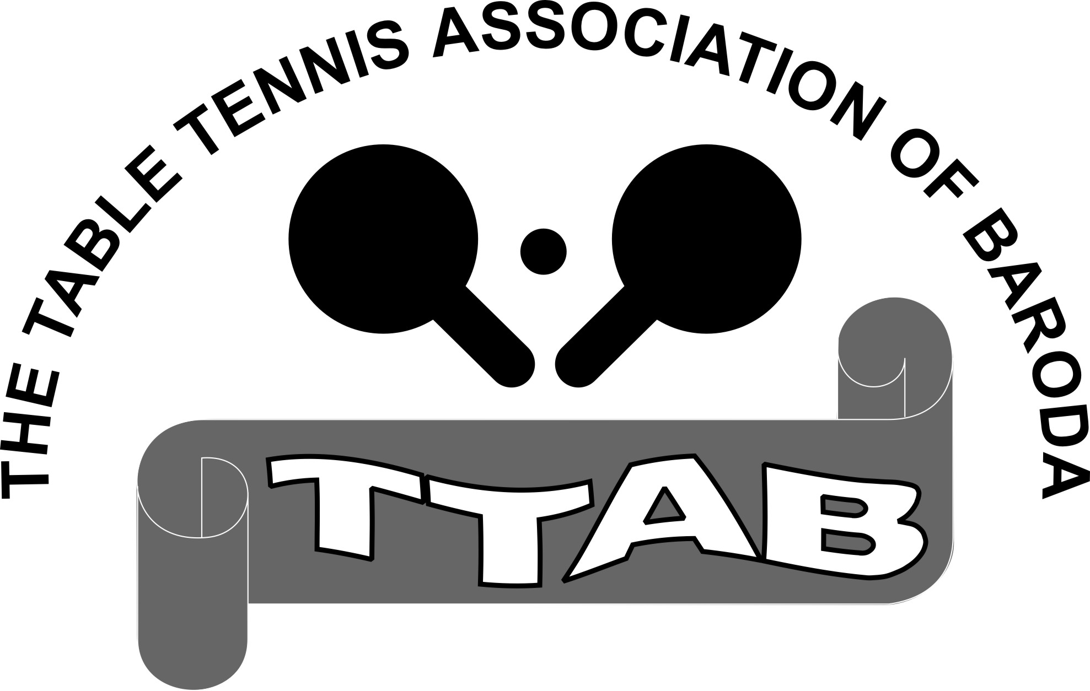
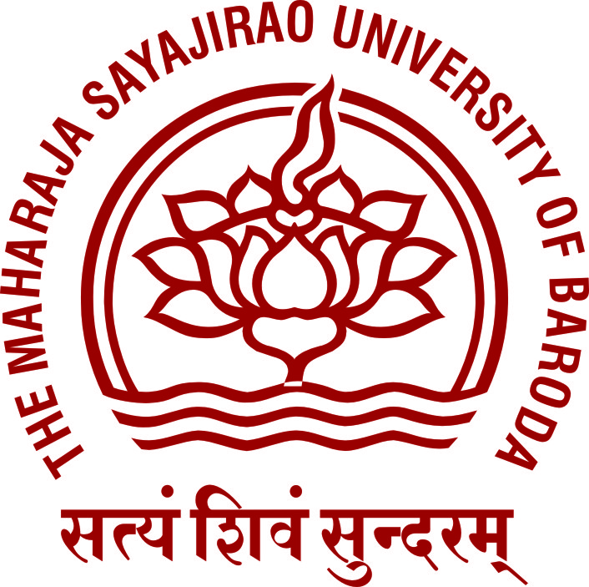
2ND OPEN BARODA MAJOR RANKING TABLE TENNIS TOURNAMENT-2017

ORGANISED BY : TABLE TENNIS ASSOCIATION OF BARODA (TTAB)

DATE : 6th - 8th July 2017

VENUE : TTAB-MSU TT Centre, Union Pavilion, The Maharaja Sayajirao University of Baroda, Fatehgunj, Vadodara.

Last date of accepting Entries: 3th July 2017 before 6:00 PM

Entry Fee per player for each event - Rs.100/-
Registration Fee - Rs.100/-

 EVENTS 

MEN’S SINGLES | WOMEN’S SINGLES | VETERAN MEN’S 40+
YOUTH BOYS SINGLES (U-21) | YOUTH GIRLS SINGLES (U-21) | VETERAN WOMEN’S 40+
JUNIOR BOYS SINGLES (U-18) | JUNIOR GIRLS SINGLES (U-18) | VETERAN MEN’S 50+
SUB JR. BOYS SINGLES (U-15) | SUB JR. GIRLS SINGLES (U-15) | VETERAN MEN’S 60+
CADET BOYS SINGLES (U-12) | CADET GIRLS SINGLES (U-12)

Organizing and Tournament Committee:

Chairperson : Smt. Jayaben Thakkar - President-TTAB
Vice Chairmen’s : Shri Rajat Bhargava - Vice President-TTAB
: Shri Jitubhai Soni - Vice President-TTAB

Organizing Secretary : Shri Kalpesh Thakkar - Hon. Secretary-TTAB
: Shri Brijesh Narigara - Hon. Joint Secretary-TTAB
: Shri Jityang Bhatt - Hon. Treasurer-TTAB

Members : 1. Dr. M. B. Ponkiya - Director Phy. Edu. Deptt. (I/c)-MSU
- Shri Vikas Prajapati - Asst.Director Phy. Edu. Deptt-MSU
- Shri J. M. Mehta - Managing Committee Member
- Shri S. T. Patel - Managing Committee Member
- Shri Bhinnang Kothari - Managing Committee Member
- Shri M. K. Nair - Managing Committee Member
- Shri H. K. Joshi - Managing Committee Member
- Shri Naresh Pawar - Co-opted Member

Referee : Shri Jityang Bhatt (International Umpire)

Dy. Referees : Shri Vishnu Sharma & Smt. Shubhangi Bhatt

Computer Expert : Shri Sunil Sharma
RULES & REGULATIONS FOR THE TOURNAMENT

- This tournament is open to all amateur players.
- Only registered players of TTAB for the year 2017 can participate in the tournament.
- Name of only those players who have paid entry fees and made application in the prescribed form will be accepted. Entry fees are non-refundable.

- It is mandatory for all players to wear uniform and proper sports shoes during practice and matches. The players will not be allowed to participate in the tournament, if this rule is not observed / followed. (Pl. note we have to preserve synthetic flooring & maintain decorum).

- Tournament Committee reserves the right to refuse any entry without providing any reason.
- Original Birth Certificate must be produced for the events of Youth, Junior, Sub Junior and Cadet. Without Birth Certificate players will not be allowed to participate in this tournament.
- The age of Youth Junior Boys & Girls must be under 21 years (Born on or after 01-01-1997)
- The age of Junior Boys & Girls must be under 18 years (Born on or after 01-01-2000)
- The age of Sub-Junior Boys & Girls must be under 15 years (Born on or after 01-01-2003)
- The age of Cadet Boys & Girls must be under 12 years (Born on or after 01-01-2006)

- The tournament will commence at 14:30 hrs on 6th July 2017 with Sub-Junior Boys event followed by Cadet Boys’, Junior Boys’ and Youth Boys’. The Men’s Singles event will commence at 19:00 hrs. Women’s and Girls’ events will commence from 7th July 2017 at 14:30 hrs and all Veterans’ events will commence on 8th July 2017 morning at 08:30 am onwards.

- The tournament will be played as per the latest rules and regulations of ranking tournament as adopted by the Gujarat State Table Tennis Association (GSTTA) & the Table Tennis Federation of India (TTFI). The decision of the Tournament Committee will be final and binding to all players.

- TTFI approved balls will be used in the tournament.
- Tournament Committee reserves the right to cancel any event, change the draw and timing of the matches, if required.

Entries should be forwarded to:

- Shri Kalpesh Thakkar, Hon. Secretary-TTAB, TTAB, TTAB-MSU TT Centre, Union Pavilion, The Maharaja Sayajirao University of Baroda, Fatehgunj, Vadodara. E-mail: kalpesh.ttab@gmail.com

- Shri Vishnu Sharma, Managing Committee Member-TTAB, TTAB-MSU TT Centre, Union Pavilion, The Maharaja Sayajirao University of Baroda, Fatehgunj, Vadodara. (M) 9898136017 (Between 6:30 pm to 7:30 pm except Sunday).

- Shri Jityang Bhatt, Managing Committee Member-TTAB, 28-Ashok Society No.1, Opp. Lions Hall, Sambhavnath Marg, Race Course, Vadodara-390007. (M) 9725013731
(E-mail: jit7965@yahoo.com).

- Dr. Vikas Prajapati, Asst. Director Phy. Edu. Deptt. - MSU, Room No.10, Union Pavilion, The Maharaja Sayajirao University of Baroda, Fatehgunj, Vadodara. (Time: 3:30 to 5:30 pm).

KALPESH THAKKAR
Hon. Secretary - TTAB

